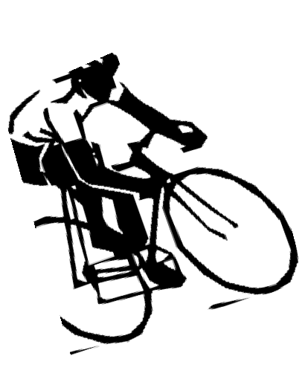
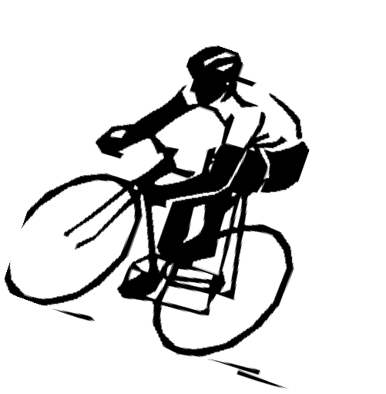
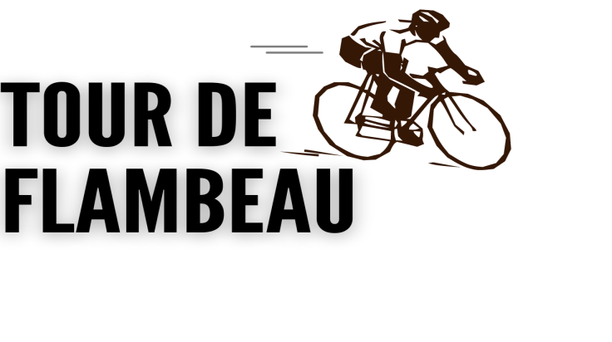

Formally known as Flambeau 40

September 2nd & 3rd, 2023
ROAD RACE - Saturday, September 2nd, 2023 - 10:00 am Start
COURSE: Juniors have the choice to ride the full Road Race or the new Juniors Road Race . The Full Road Race is a Thirty-five (35) mile loop consisting of rolling hills. The Junior Race will be a Six (6) mile loop on mostly level roads. Both races will stage at the Park Falls Community Room, 400 4th Ave. S., Park Falls. Starting line for both will be at the intersection of 5th Ave S and 4th St . Check website for detailed course information at www.parkfalls.com.
SCHEDULE: Registration 7:30 AM to 9:30 AM – Park Falls Community Room, 400 4th Ave. S., Park Falls
Road Race starts at 10:00AM, Junior Race starts at 8:30 am, (Must pre Register in advance for Junior Race) FREE Kids race to start after Road Race begins

AWARDS: Road Race and Junior Race will have special awards to top overall male and female finishers.

SPECIAL NOTES: Professional Chip Timing. Water and fruit available before race. Lunch available after race.

NO Aero Bars allowed. *(Minor road changes possible)*

TIME TRIAL - Sunday, September 3rd 2023
Course: A twelve (12) mile total ride with the majority of the terrain being flat and straight.
Schedule: Registration 7:00AM to 8:30AM –American Legion Hall 182 274 N 3rd Ave Park falls Wi 54552. Pre-Registration is strongly encouraged. Start times will be assigned sequentially as registrations are received with the first racer being released at
9:00am. Racers will be released onto the course on 1 minute intervals and MUST report to starting area with bib number at least 5 minutes prior to assigned start time. Start times will be published on the chamber website: www.parkfalls.com
Awards: Special awards to top overall male & female finishers; and certificates to the top 3 finishers in each WISport age class.
Special Notes: Professional Timing. Water and fruit available before race. Aero Bars are allowed.
TOUR DE FLAMBEAU REGISTRATION AND RELEASE FORM
NAME

ADDRESS
CITY STATE ZIP
Register online at
ParkFalls.com or

EMAIL

PHONE
AGE ON RACE DAY: GENDER: (Circle One) MALE FEMALE
WiSport ID # # Years Raced
Additional Lunches are available for non racers ($10.00 Each) (must be ordered by 8/9) EMERGENCY CONTACT NAME/PHONE:

REGISTRATION INFORMATION
REGISTRATIONS ARE ACCEPTED ON THE
DAY OF THE EVENT!
MAIL REGISTRATION & PAYMENT TO:
PARK FALLS AREA CHAMBER OF COMMERCE 154 N. 4th Ave, PARK FALLS, WI 54552
CALL WITH QUESTIONS: (715) 762-2703
X
ADULT PRICES Please check one:
35 MILE ROAD RACE ONLY: $40
TIME TRIAL ONLY $20
ROAD RACE & TIME TRIAL $50
Junior (18U) PRICES
35 MILE ROAD RACE ONLY OR $20
6 MILE ROAD RACE ONLY $20
TIME TRIAL ONLY $10
ROAD RACE & TIME TRIAL $30
FREE RACE (6 & UNDER) FREE
Saturday at 10:10 after main race starts
wi-sport.com

I realize that cycling is a dangerous sport and can cause death, injury, and property
damage. I hereby promise to assume these risks, hold harmless, and waive any and all race promoters, volunteers, municipalities, citizens, and any associated organizations. I further certify that I am physically fit to participate in the above named event. I understand that the Park Falls Area Chamber has the right to prevent me from participation in the bike race without my signature on the race form.
Office Use Only
Bib#

SIGNATURE OF PARTICIPANT/PARENT OR LEGAL GUARDIAN IF UNDER 18

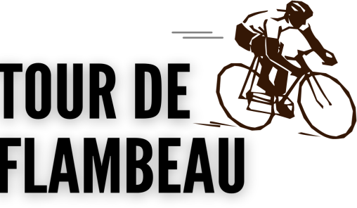
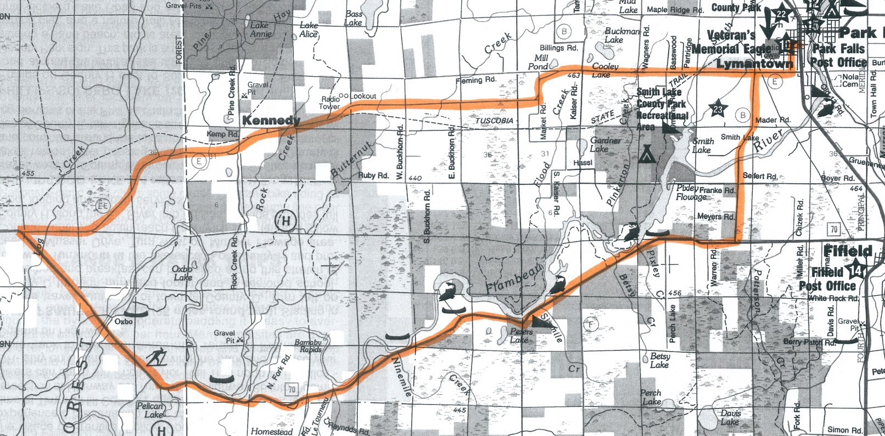
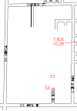

Course Maps
Road Race Course Map & Description
Thirty-five (35) mile loop consisting of rolling hills. (Minor road changes possible)
Starting line at the intersection of 9th Avenue South and Division Street. Proceeding East on Division Street turn right on 5th Ave South to County Hwy E turn left onto County Hwy. B. Proceeding south, turn right onto Hwy. 70. Proceeding west, turn right onto County Hwy. EE. Proceeding east, to 5th Ave South turn left to finish line at 4th Street South.

Kids race (6 and under) will go from Division and 5th to the finish line at 4th Ave South in front of the Chamber.
Time Trial Course Map & Description
TOUR DE FLAM-
BEAU And Kid Race Finish line
EVENT
REGISTRATION
Park Falls Community Room
400 4th Ave. S Park Falls, WI
Junior race will be two laps
TOUR DE
FLAMBEAU
Start
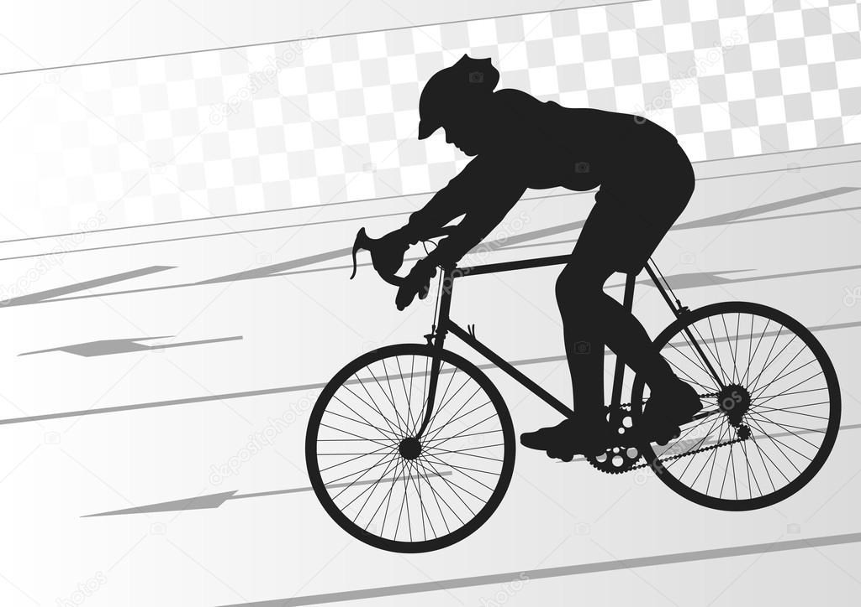
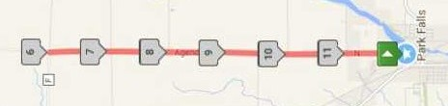
A twelve (12) mile out and back ride with the majority of the terrain being flat and straight.

The starting line is on North 1st. Ave. Proceed north to Agenda Road. Continue north on Agenda Road until it intersects County F and Blueberry Road (at the Grove Tavern). Here you will turn around and continue on Agenda Road heading south, back to the start/finish line.
EVENT REGISTRATION
American Legion Post 182 Hall 274 N 3rd Ave
Park Falls WI 54552 (Approx 2 blocks to the South/
West of Start/Finish line)

