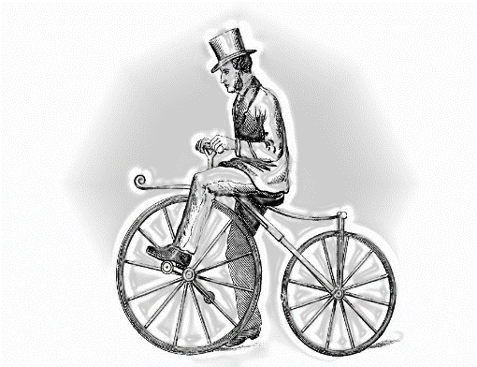
TIME TRIAL | ROAD RACE
June 29 | June 30
≈ 10 miles | ≈ 19 or 38 miles
Registration opens 11 AM | Registration opens 8:30 AM-ish
First rider off 12:30 PM | Racers off ≈ 10:30 AM

WASBURN WISPORT CHALLENGE
TIME TRIAL & BIKE RACE

June 29-30, 2024
Washburn, WI

DAY-OF TT REGISTRATION: Bayview Town Hall; Maki Road. Washburn, WI
DAY-OF RACE REGISTRATION: THE CLUB @ 3 West Bayfield St.
Washburn, WI 54891

COST [no extra day-of costs!]:
TT: $30 per rider
RR $40 per rider $60 per rider FOR BOTH! ($10 discount)
$15 for all juniors, per race (under 18) or $20 for both events
Awards for 1st place overall Male & Female; 1st- 3rd place given for age groups in 5-year increments (e.g.: 20-24, 25-29, etc.)

Hosted by Wisport and Sponsored by Tamarack Health
www.wisport.net

Registration available online at MidwestEvents.com
WASHBURN WISPORT CHALLENGE BIKE RACE REGISTRATION FORM
Make Check payable to WISPORT (or ANDREA POTYONDY-SMITH)
Send to: 910 West Bigelow St. Washburn, WI 54891
Phone: 763-639-5126 or 763-898-6065 (RJ) Email: adurene@hotmail.com

Last Name First Name Phone Number

Address City State Zip Code

Age:______ DOB (mm/dd/yy):_____________ Gender (M/F):________

CHECK ONE: Time Trial _______ Road Race_______ BOTH Events _____

Are you a WiSport Member? (circle one) YES NO If Yes, ID #:____________

_____TT ($30) _____RR ($40) _____BOTH ($60)

____ Junior Single Event ($15) _____ Junior Double Event ($20)

WAIVER: By signing this form, I acknowledge I plan to participate in the Washburn Wisport Challenge Bike Race and Tour; I thereby waive, release, and dismiss all claims from damages and personal injury which I may incur before, during, or after the above named event(s) against any and all race officials involved with this event(s), including all persons and organizations any way involved with this event(s). I also hold harmless Bayfield County, WI, and the townships of Washburn & Bayview, WI, including all their departments and officers. I further certify that I am physically fit to participate in the Washburn Wisport Challenge Classic Race and Tour.

Signature of Participant Date

___________________________________________________________________
Signature of Parent, if under 18 Date

